Diversity, Equity, Inclusion in the State Workforce
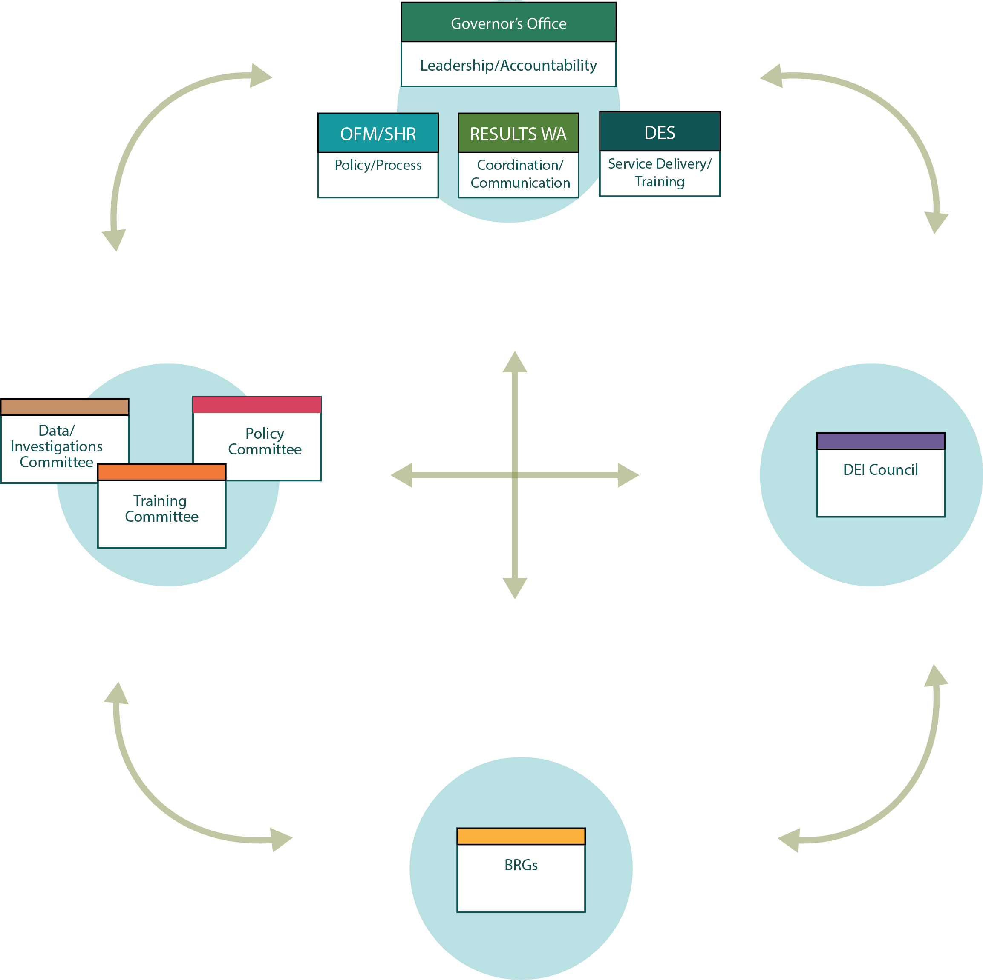

DEI Committees
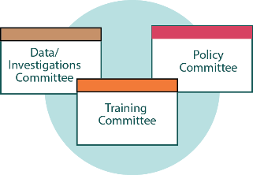
Comprises 58 members from cabinet agencies and various boards and commissions. Committee members come from a variety of backgrounds — not just HR — and lend a diversity of thought and experience.
Serves as working groups to complete the action items identified in the governor’s inclusive and respectful work environments memo from April 2018.
Scope based on the governor’s memo:
- Policy Committee: develops model policies to implement DEI strategies and processes.
- Training Committee: develops timely, informed and targeted learning to increase knowledge and skills in the workforce, which strengthen a culture of respect and inclusion.
- Data and Investigations Committee: improves how data is collected and used to assess agency work environments and offers refinements to employee complaints and personnel investigation processes
DEI Council
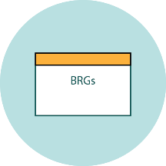
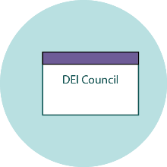
Composed of 27 members from higher education, cabinet agencies, other groups. Majority are HR practitioners.
Serves as the state’s DEI advisory and coordinating group. It develops recommendations on statewide policies and strategies and provides input on DEI issues raised by agency HR directors.
Scope is fluid to address emerging needs of the enterprise. Focus areas for this year are:
- Hosting an annual DEI event
- Created a DEI employee life cycle road map to identify areas of influence State HR has in building a respectful, inclusive workplace.
- Reviewing and revising eLearnings offered by Department of Enterprise Services, including hiring process for supervisors, interview skills for panelists, respect in the workplace and sexual harassment prevention.
Business Resource Groups/Networks
Composed of hundreds of employee members from cabinet agencies, boards and commissions. Employee members come from all levels of the organization and types of work.
Serve as a grassroots-driven structure for employees to address the unique needs and issues of our diverse workforce.
Scope is to improve workplace culture and shed light on specific issues or barriers that may negatively affect certain groups of employees by implanting strategies and making recommendations. Each group is a strategic tool for advancing organizations’ cultures, including the recruitment of diverse talent.
- Veterans Employee Resource Group: looks at how to include veterans
- Rainbow and Inclusion Network – looks at how to include LGBTQ+ employees
- Washington Immigrant Network – looks at how to include immigrants
- Disability Inclusion Network – looks at how to include employees with disabilities
- Latino Leadership Network – looks at how to develop leadership skills of Latinos; will transition to a statewide business resource group by the end of 2018

