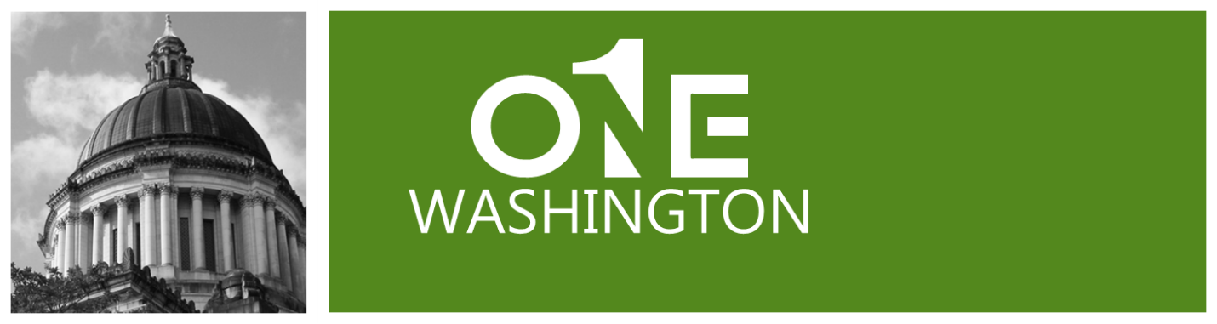

Exception Criteria and Justification Form for Agency Budget Requests
  - 2021-23 Biennial Budget
DESCRIPTION | This document outlines the exception criteria and justification form for the 29 agencies who are not included in the list of agencies who have been pre-approved to submit OneWa budget requests as well as the 15 pre-approved agencies who have additional finance system/interface resource needs not already identified. It contains two key components:  - A description of circumstances that warrant agencies to submit an exception form.  - The justification criteria form and routing information for submission to the OneWa program team.
PURPOSE | Use this form to determine whether your agency is eligible to submit an OneWa-related budget request.
AUDIENCE | Legislative Evaluation and Accountability Program Committee (LEAP)  Joint Legislative Systems Committee (JLS)  Administrative Office of the Courts (AOC)  Office of the State Treasurer (OST)  Office of the State Auditor (SAO)  Office of the Attorney General (ATG)  Dept. of Financial Institutions (DFI)  Dept. of Commerce (COM)  State Health Care Authority (HCA)  State Lottery Commission (LOT)  Dept. of Retirement Services (DRS)  State Investment Board (SIB)  Dept. of Revenue (DOR)  Consolidated Technology Services (CTS)  Liquor and Cannabis Board (LCB)  Washington State Patrol (WSP)  Washington Traffic Safety Commission (STS)  Dept. of Labor and Industries (L&I)  Dept. of Children, Youth and Families (DCYF)  Student Achievement Council (SAC)  Superintendent of Public Instruction (SPI)  University of Washington (UW)  Washington State University (WSU)  Eastern Washington University (EWU)  The Evergreen State College (TESC)  Western Washington University (WWU)  Transportation Improvement Board (TIB)  Community and Technical College System (CTCS)  Department of Services for the Blind (DSB)

Biennial Budget Exceptions: Information and Exception Criteria
In the fall of 2019, the One Washington program conducted a systems and interfaces inventory with agencies to assess the impact of the implementation of an enterprise resource planning software solution on their interfaces and systems. As a result of this effort, 44 agencies had identified impacts.
Of the 44 agencies with finance impacts, 29 agencies need to review this form to identify whether they qualify to submit an OneWa budget request. Please use the process below to determine whether you are eligible to submit an OneWa-related budget request for consideration by the OneWa team.
As a reminder, the following agencies are eligible to automatically submit a budget request –:
Office of the Secretary of State (SEC) | Department of Transportation (DOT)
Office of Financial Management (OFM) | Department of Ecology (ECY)
Department of Enterprise Services (DES) | State Conservation Commission (SCC)
Utilities and Transportation Commission (UTC) | Department of Fish and Wildlife (DFW)
Department of Licensing (DOL) | Department of Natural Resources (DNR)
Department of Social and Health Services (DSHS) | Department of Agriculture (AGR)
Department of Health (DOH) | Employment Security Department (ESD)
Department of Corrections (DOC)

If you were a part of the remaining 29 agencies who have identified system and interface impacts OR your agency is one of the 15 pre-approved agencies and you have identified additional finance system/interface resource needs, please follow these steps to determine whether your agency is eligible to submit a request for exception to the OneWa program team.
Step 1. Your agency is eligible to apply for an exception if it meets any of the following criteria:
- Complex interfaces:
  - Use MQ integration platform.
  - Are a FAST agency (DOL, ESD, DOR).
  - Maintain agency mainframe applications.
  - Use Microsoft Dynamics, PeopleSoft, SAP and other ERP implementations that interface directly to AFRS.
- Your agency has no internal technical skill to support interface modifications.
- There were mission-critical systems/interfaces missed on the spreadsheet you submitted in 2019.
  - Definition of mission-critical: Widespread business stoppage with significant revenue or organizational impact; Risk to human health/environment; Public, wide-spread damage to organizations reputation.
- Your agency’s chart of accounts is hardcoded, and you need to understand the level of change required to meet the new, enterprise-wide chart of accounts model.
- Your agency’s interfaces are maintained by a third party.
- You are a small agency with less than 50 employees.
- Your agency system is considered mission critical to state and interfaces directly with AFRS (ProviderOne, TM$, DRS and DSHS systems, etc.).
- Legislative mandate-new, mission critical & unfunded that would impact the state’s financial system.
Step 2. Your agency is not eligible to apply for an exception if/for:
- New interface/system-modifications covered in base funding.
- Mainframe interfaces for re-platforming.
- Webi reports/interfaces.
- ADDS interface replacement.
- Financial Toolbox replacement.
- Currently in M&O budget.
- Procurement impacts.
If you have determined that your agency is eligible to submit an OneWa-related budget request, please complete the form below and submit to OneWa@ofm.wa.gov by July 10, using Budget Justification Form as the subject line in the email.

Justification Criteria Form

Form Instructions
The template below is intended to help your agency submit a justification to explain why you should be eligible to submit an OneWa-related budget request. Please submit the completed form to onewa@ofm.wa.gov . OneWa team will reach out to you for an initial meeting and next steps with this request.

How long does the review take?
Depending on the scope, size, and complexity of the criteria, the review may be done very quickly by subset of the IT/Business only, or by all members of OneWa team.
If your exception request is approved, OneWa will provide you with an agency resource calculation tool pre-populated with your identified impacted systems and interfaces as well as guidance regarding how to calculate resource needs. The completed resource calculation tool will need to be submitted to OneWa (onewa@ofm.wa.gov) by August 15th, 2020 to be considered for inclusion in the OneWa decision package. No late submission will be accepted.
For any questions on the process, please contact onewa@ofm.wa.gov or review the OneWa 2021-23 Agency Budget Development Process on the OneWa Budget Resource Page

bUDGET JUSTIFICATION CRITERIA FORM

Business Context
Name of Application or Product

Employee Name/Business Unit Requesting Application or Product

Provide brief justification for software/upgrade or change.

Does this software build new or enhance existing business capabilities? Provide a brief description of business process(es) supported.  {Leave Blank if Unsure} | ☐ Builds New  ☐ Enhances Existing  ☐ No Change
Has this been submitted to OCIO prior? If so, can you please include link to the OCIO dashboard item. | Yes No  ☐ ☐

Data Architecture
Indicate the categories of data that can be used in this software solution. Provide a brief description of the data items. {Link to Data Category Definitions} | ☐ Category 1  ☐ Category 2  ☐ Category 3  ☐ Category 4
Does the solution support high-volume and/and or high-frequency data transfers? Please describe the limits allowed. | Yes No  ☐ ☐

Application\Infrastructure Architecture
Does the software solution include Application Programming Interface (API) to access data or software features? What type of APIs? What security level | Yes No Unsure  ☐ ☐ ☐

Records Management
Is this product your agency system of record? | Yes No  ☐ ☐

Security Architecture
Does this system support regulations/laws? (Example: Federal Highway, etc.) Please describe in detail the system that has that regulation. | Yes No  ☐ ☐
Please describe what other security requirements are needed? (Example: PCI, HIPPA, etc.)

Costs
What is the cost estimate of the budget request? Based on the review of this application, your agency may be asked to fill out the OneWa Agency Resource Calculation Tool to determine definitive price of the budget request.

