**

Submitting Vendor Forms with DocuSign™

The Vendor forms can be signed electronically with a digital signature via DocuSign™. Unfinished/unsigned forms will be voided on the next business day.

The Statewide Vendor/Payee Services provides the following forms that can be signed via DocuSign™:

* [Vendor/payee Registration form](https://na4.docusign.net/Member/PowerFormSigning.aspx?PowerFormId=2d932d15-546f-4a73-a839-f07c3fb38f71&env=na4&acct=97b8a9fd-298c-4ddf-a75e-44611183f8f7&v=2)  (DocuSign™)
* [Vendor/payee Change form](https://na4.docusign.net/Member/PowerFormSigning.aspx?PowerFormId=45d71f96-ea91-4836-8aef-dc20d0ee27f0&env=na4&acct=97b8a9fd-298c-4ddf-a75e-44611183f8f7&v=2) (DocuSign™)
* [Direct Deposit Authorization form](https://na4.docusign.net/Member/PowerFormSigning.aspx?PowerFormId=3e1684d1-284e-46dc-917a-4b348ddbd9ab&env=na4&acct=97b8a9fd-298c-4ddf-a75e-44611183f8f7&v=2) (DocuSign™)

Follow the instructions below to sign your forms and your electronic signature will be accepted.

Please note that the example below is for the Vendor/payee registration form but it’s applicable to other forms.

Validating your email with access code

* Open a form with link provided above. You will be directed to this page:

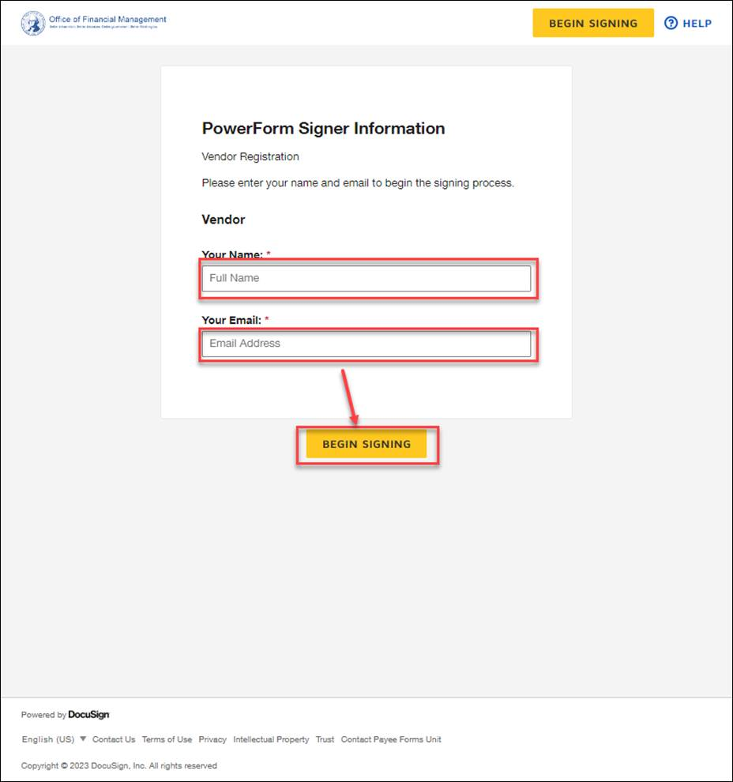

Enter your name, your email address (make sure it’s correct) and select the **BEGIN SIGNING** button.

* Open your mailbox (with the email address you sent), **if you do not see the email, please check your spam folder**. The email will look similar to this:

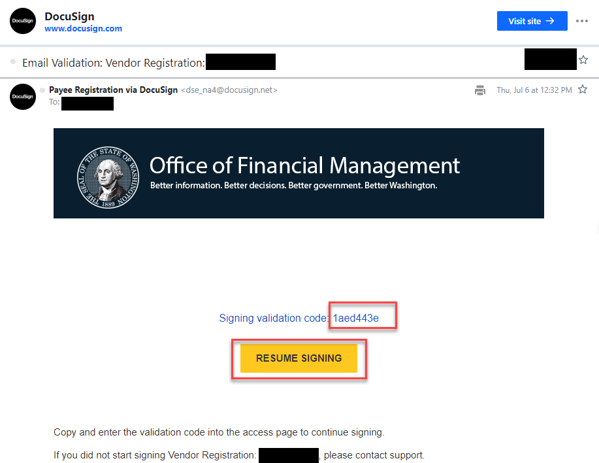

* Copy the entire code and select the **RESUME SIGNING** button or go the authenticate page:

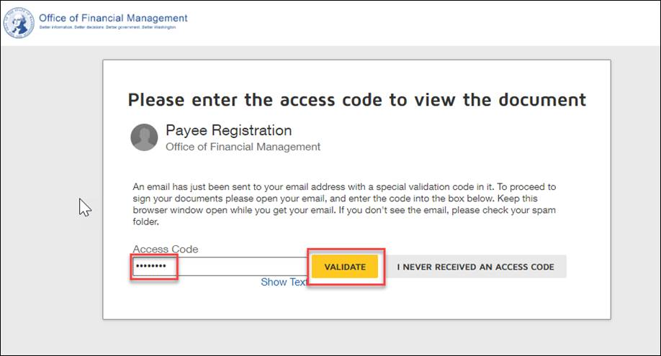

Enter the code, click outside the **Access Code** box or select **“Show Text**” to activate the **VALIDATE** button, select the **VALIDATE** button.

Signing the form via DocuSign™

* After validating your access code, you will be directed to this page:

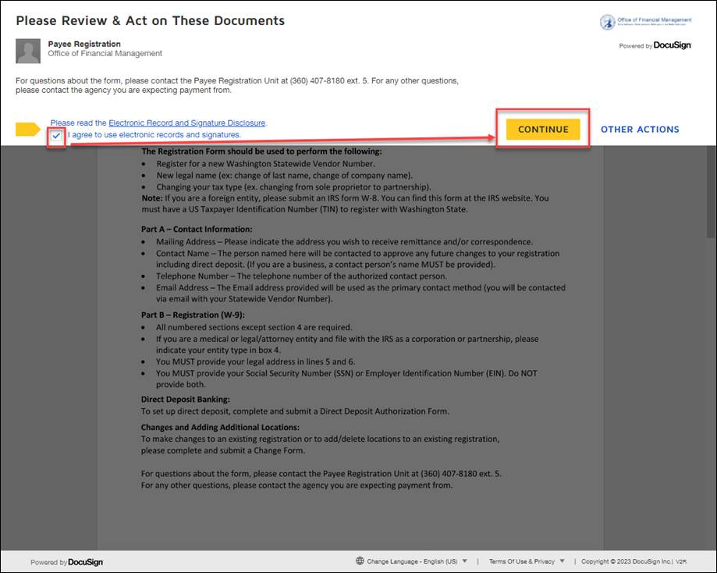

If you agreed with the **Electronic Record and Signature Disclosure**, check the “**I agree to use electronic records and signatures**” checkbox and select the **CONTINUE** button.

* The form opens, select the **START** button and follow the instructions to fill out all the required fields:

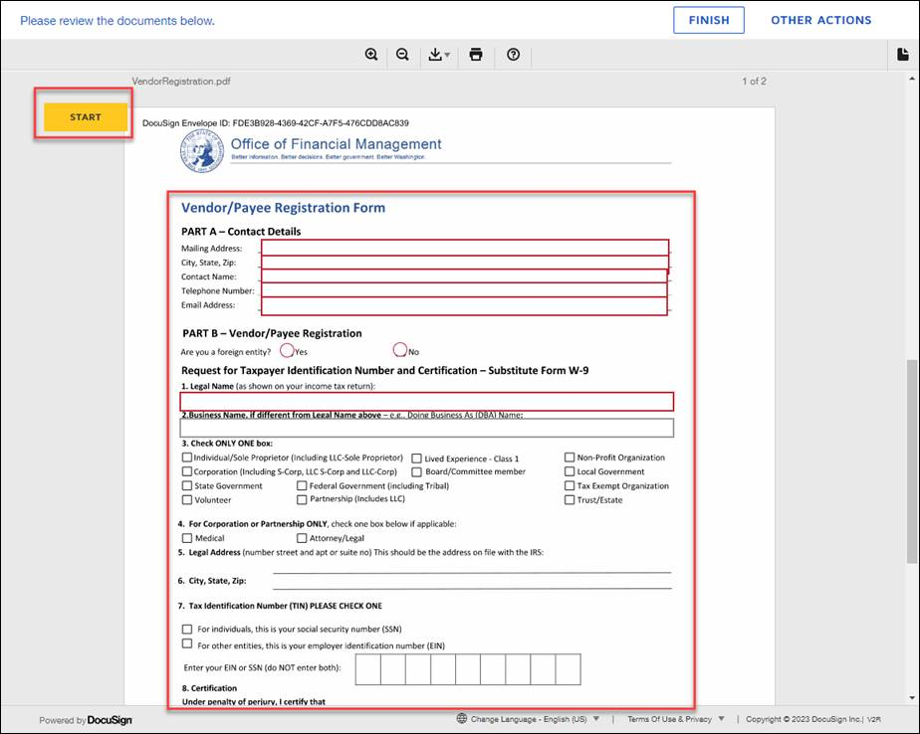

* Once you’re done filling out all the required fields, select the **Sign** button at the bottom of the page, a popup window opens:

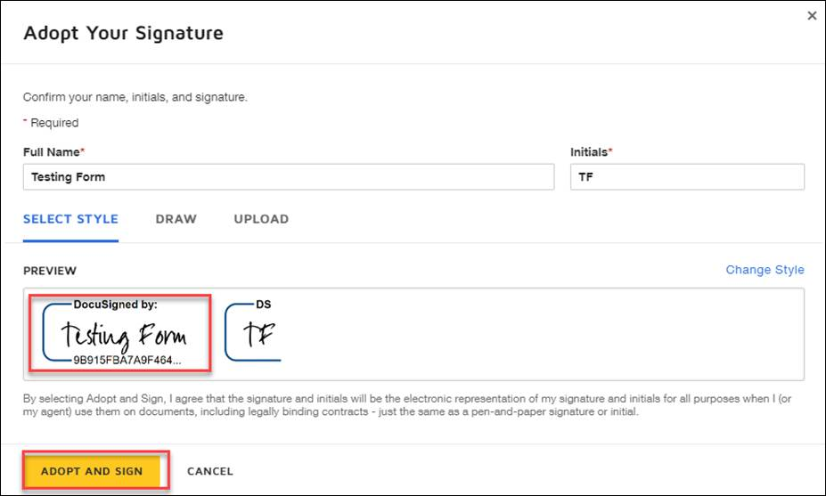

Accept the default signature by selecting **ADOPT AND SIGN** button or make change using “**Change Style**”, or use **DRAW** tab to draw your signature, or use **UPLOAD** to upload image of your signature.

**Make sure you sign with your name, not the business name.** If the Preview box shows the business name, change it to the signer’s name.

* Select the **ADOPT AND SIGN** button when done. A popup window opens:

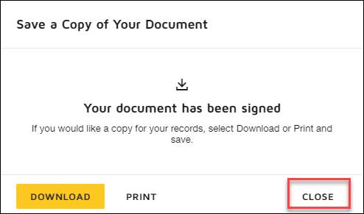

Select **DOWNLOAD** or **PRINT** to review your signed form. Otherwise, select the **CLOSE** button.

* Select the **CONTINUE** button on the next window:

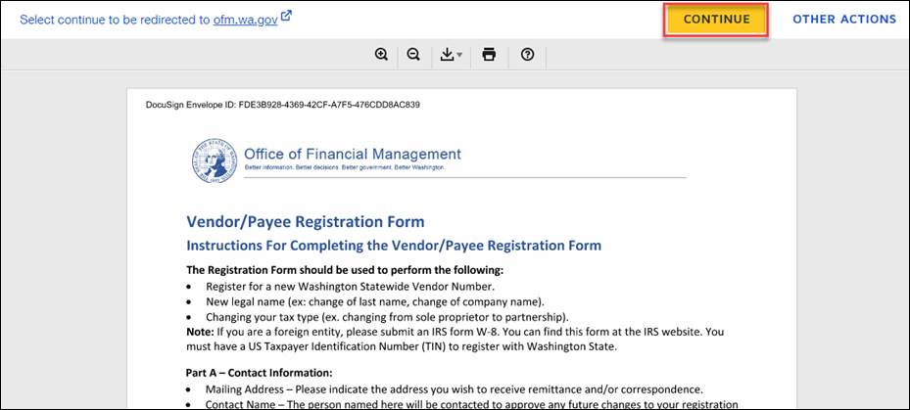

* You will be directed to the confirmation page:  
  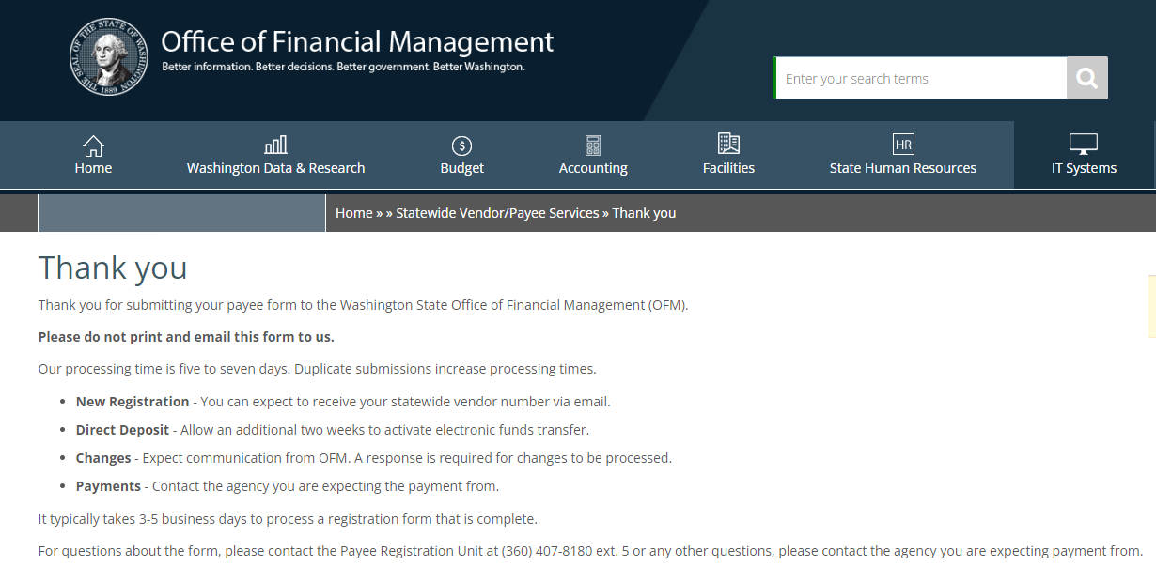
* Check your mailbox, you will receive a confirmation email with the signed form attached:

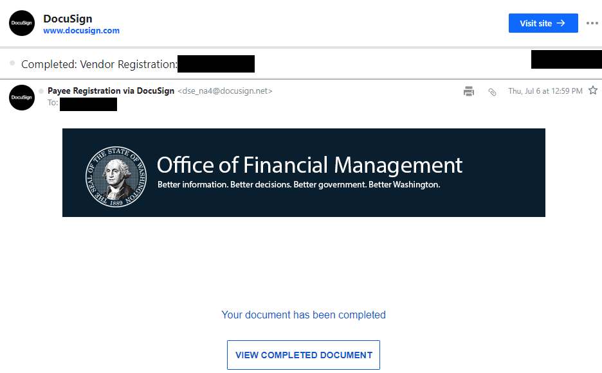

You can save the attached form for reference **but do not email the form to us**.

This concludes your signing process.

It typically takes 3-5 business days to process a registration form that is complete. Unfinished/unsigned forms will be voided after 24 hours.

For questions about the form, please contact the Payee Registration Unit at (360) 407-8180 ext. 5 or any other questions, please contact the agency you are expecting payment from.