Leave Approval Reporting Structure
Purpose | This document will guide you in creating your agency’s Leave Approval Reporting Structure.
Trigger | Your agency has decided to utilize the Leave Approval process in MyPortal.
Prerequisites | All components are required for agencies to use the MyPortal leave request process.

Before you begin | You will need to have all the org units identified. They should reflect the leave approval reporting structure.  Example – Before  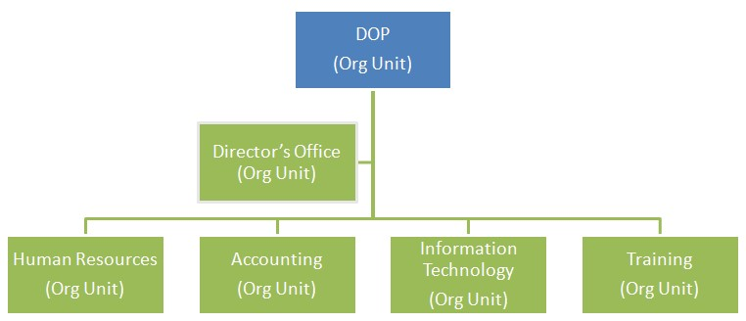  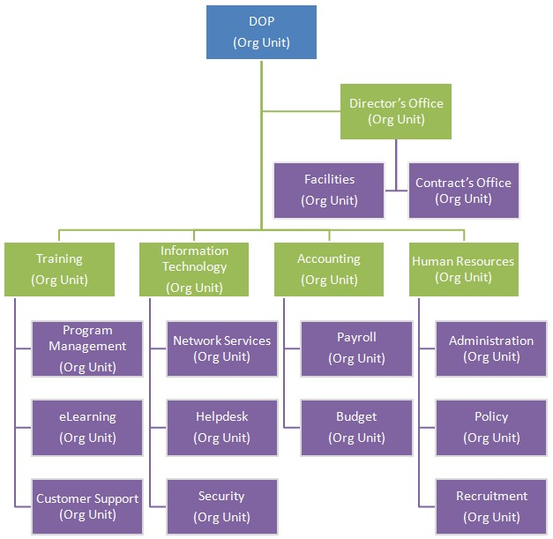  Example - After
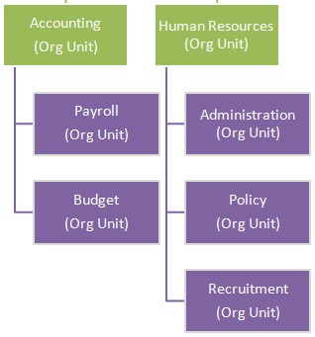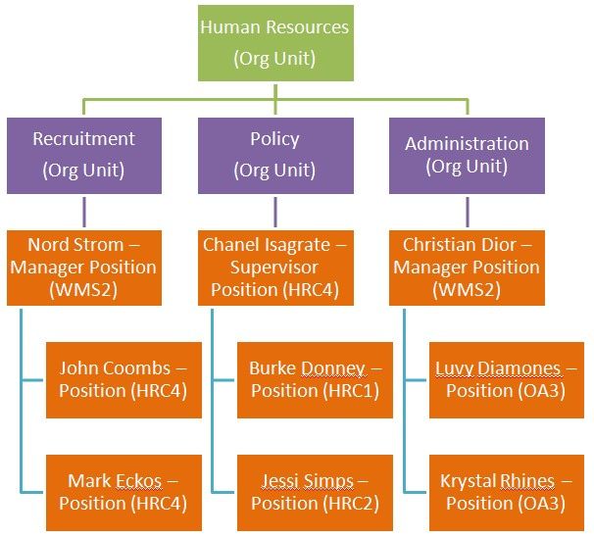
s
Guideline

Org
anizational

Units

I
dentif
y

all org units

that exist in your agency
.

Y
ou will need to create
the org
units
that

reflect
down
to the lowest level reporting structure.

Example:

For instructions on creating a new org unit, see OLQR P
rocedure:
g
Or
anizatio
n

e
Unit Creat
.

Employ
ee Positions

Identify the
positions that are

in each org unit and assign them
to

the correct
org unit

in

HRMS.

Example:

For instructions on creating a Position to Org Unit relationship, see OLQR
Procedure:
Position to Organizational Unit

-

Maintai
n
.

All the
purple

colored
sub org units will ne
ed
to be created in HRMS.

All the
orange

colored positions
will need to have the ‘Belongs
to‘relationship created.

Managers/Supervisors | All the red colored positions will need to have the ‘Manages‘ and ‘Is line supervisor of’ relationship created.  Identify the Managers/Supervisors positions in all the agency org units and assign them the relationship type A012 – Manages to the org unit. This is also referred to as the ‘Chief’ relationship. The Managers/Supervisors positions also need to be assigned the relationship type B002 - Is line supervisor of for the positions that directly reports to it.  Example:  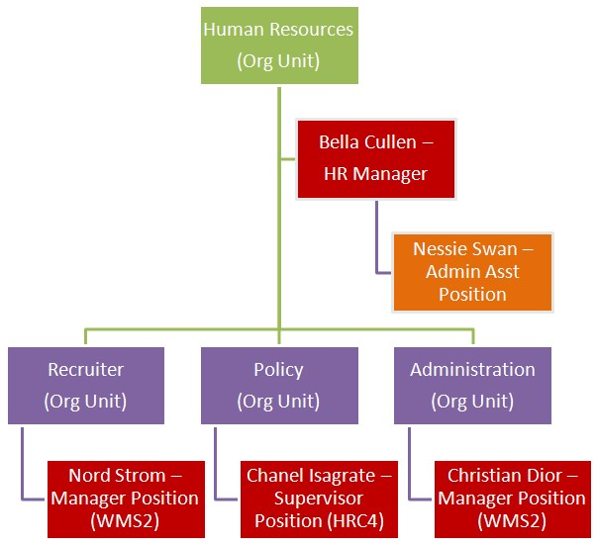  For instructions on creating the Position to Org Unit Manages relationship and Position B002 relationships, see  ESS – Create Position to Org Unit Manages (Chief) Relationship and Relationships – Supervisor Position to Subordinate Position - Create New Record

Other Related OLQR Procedures
- Multi-filled Chief Position User Procedure
- Relationships – Supervisor Position to Subordinate Position
- ESS – Create Position to Org Unit Manages (Chief) Relationship
- ESS– Vacant Chief Position
- Organization Unit Create
- How to Identify Position to Position Relationship Report
- Position to Organizational Unit – Maintain

HRMS Organizational Structure Example
The below screenshot is an example of a completed Leave Approval Reporting structure.

Legend:
Organization Unit
Chief Position
Position
